Spendwise Important Points

Why do we need cookies?
Problem:
middleware.ts runs on the SERVER
localStorage exists only in the BROWSER
Server cannot read localStorage!

Solution:
Save token in BOTH localStorage AND cookie
Browser sends cookie automatically with every request
Middleware on server can read the cookie

Login happens
↓
Save token to localStorage ← for browser JS (Axios interceptor)
Save token to cookie ← for server (middleware route protection)
↓
User visits /dashboard
↓
middleware.ts runs on server
↓
Reads cookie → token exists → allow access

Where cookies are created in our project
We already wrote the cookie helpers in useAuthStore.ts. But let me make sure they are correctly implemented. Open apps/web/store/useAuthStore.ts and verify these two helper functions exist at the top:
After login:
┌──────────────────────────────────────────────
│ localStorage['spendwise_token'] = "eyJ..."
│ → Used by: Axios interceptor (api.ts)
│ → Attaches to every API request automatically
└──────────────────────────────────────────────

┌──────────────────────────────────────────────
│ Cookie['spendwise_token'] = "eyJ..."
│ → Used by: middleware.ts
│ → Protects /dashboard, /expenses etc.
└──────────────────────────────────────────────

After logout:
Both are deleted → user is completely signed out

Why put API calls in a hook instead of directly in the page? Because the page component stays clean and readable. The hook handles loading, error, and data state in one place. Multiple components can reuse the same hook.

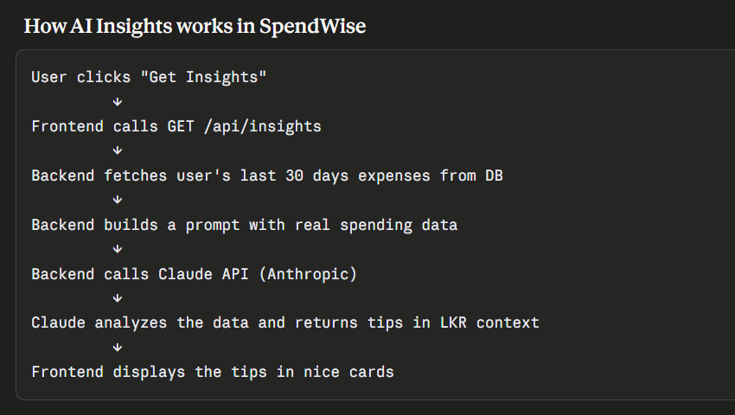

Gemini API Key = AQ.Ab8RN6JtLpHr-X399xMdltMeKN98-xivIbtH6waSS6Jb4CRDzA

Claude api key= ‘sk-9fb5a0dea035427c9f362adcf1ed5187’

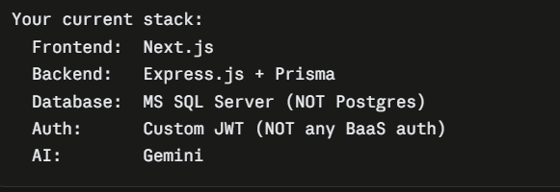

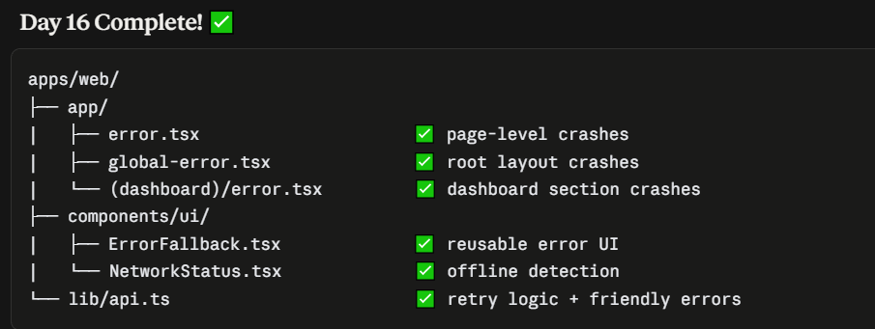

Run test cases:
Run all test cases: npm run test
Shows a table of what percentage of each file is actually exercised by tests:
npm run test:coverage

- Docker → packages your backend into a portable container
that runs identically on any machine
- GitHub Actions → automatically runs your tests every time you
push code or open a pull request
in Dockerfile
multi-stage builds:
Stage 1 has everything needed to BUILD the app (TypeScript compiler, all packages).
Stage 2 only copies the final compiled result. This is exactly how professional companies ship Node.js apps — smaller image, faster deploys, fewer security vulnerabilities since dev tools aren't shipped.

Dockerfile = tells Docker how to build ONE container.
docker-compose.yml = tells Docker how to run and connect MULTIPLE containers/services together.

To create new file: PowerShell
New-Item -ItemType File -Name "docker-compose.yml"

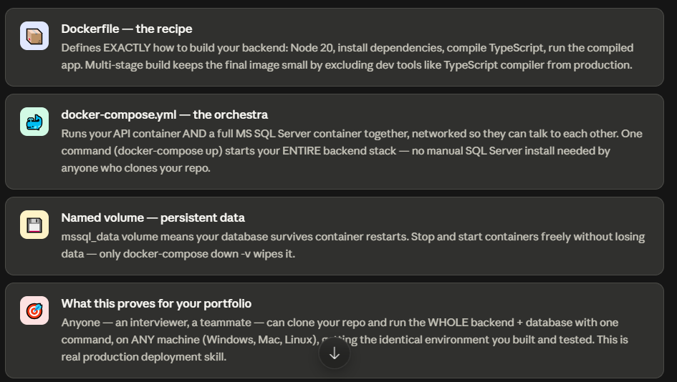

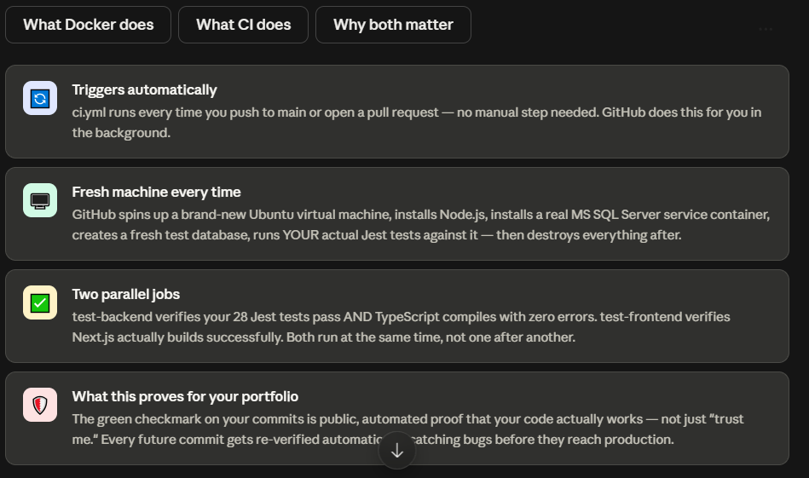
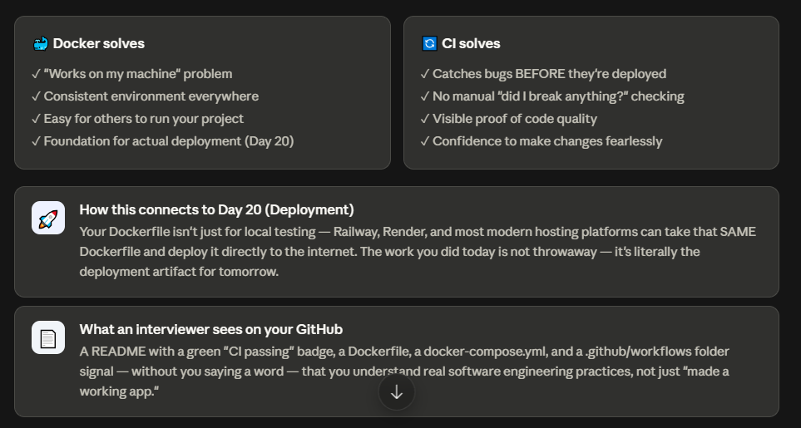

DB Host Server: https://console.neon.tech/app/projects/lucky-fog-17993504?database=neondb

Root endpoint: https://spendwise-backend-eight.vercel.app/
Health check: https://spendwise-backend-eight.vercel.app/api/health

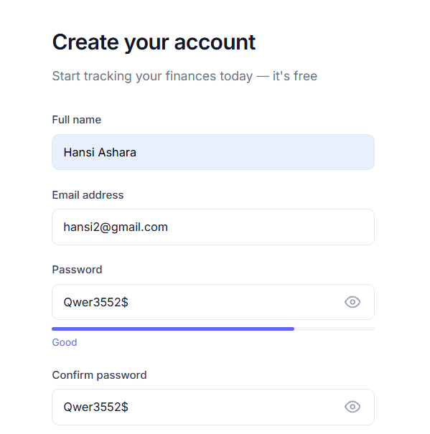
https://spendwise-web-zeta.vercel.app/

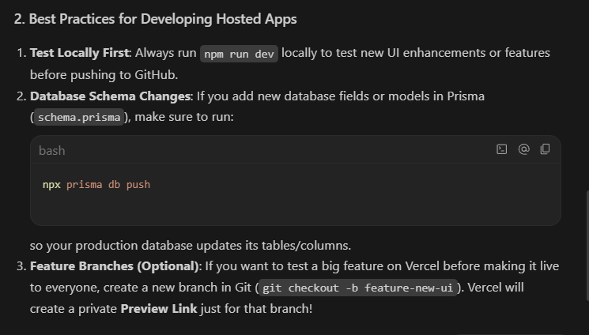

Never reveal if an email exists — the forgot-password endpoint always returns the same success message, whether or not that email is registered. This prevents attackers from using it to discover valid accounts.

Expenses and Budgets are intentionally independent features
Expenses = a record of what you actually spent
Budgets = a goal/limit you set for yourself

They don't need each other to exist.
Think about how real people use money apps:
Scenario 1 — New user, day one
User signs up, wants to just start logging expenses immediately
→ "I bought lunch for 450 LKR" — logs it right away
→ Hasn't thought about budgets yet, and that's fine
If we forced users to set a budget before logging any expense, that would be a huge friction point — most people would just abandon the app on day one.
The real purpose of this flexibility
1. Budgets are optional, expenses are the core data
Your app's fundamental job is tracking spending. Budgets are a layer on top that helps users control spending once they understand their patterns. Making budgets mandatory-first would be backwards — you can't set a realistic Food budget until you've seen a few weeks of actual Food spending.
2. Some categories may never need a budget
A student might want to track "Health" expenses just for their own records, without ever wanting a strict monthly limit on health spending — you don't want to limit healthcare spending, just see it.
3. It matches how your Budget system actually works

Expenses are the source of truth, and budgets are just an optional lens you apply on top to see "how am I doing against my goal for this category."

Future enhancements:
On the Dashboard or Expenses page, if a category has significant spending but no budget set, show a subtle suggestion like:
You've spent LKR 8,500 on Food this month with no budget set.
[Set a budget →]

